Status™ COVID-19
Rapid Immunoassay for Direct Detection and
Differential Diagnosis of SARS-CoV-2 Antigen

For In Vitro Diagnostic Use Only
For Rx Use Only
For use under an Emergency Use Authorization only

Catalog No. 33125

Intended Use
Status™ COVID-19 test is a lateral flow immunoassay intended for the in vitro rapid qualitative detection of nucleocapsid antigen from SARS-CoV-2 directly from nasopharyngeal or nasal swab specimens obtained from patients with signs and symptoms of respiratory infection, who are suspected of COVID-19 and by their healthcare provider, within the first five days of onset of symptoms. It is intended to aid in the rapid differential diagnosis of SARS-CoV-2 infections. Testing is limited to laboratories certified under the Clinical Laboratory Improvement Amendments of 1988 (CLIA), 42 U.S.C. §263a, that meet the requirements to perform moderate complexity, high complexity, or waived tests. This test is authorized for use at the Point of Care (POC), i.e., in patient care settings operating under a CLIA Certificate of Waver, Certificate of Compliance, or Certificate of Accreditation.

Results are for the identification of nucleocapsid antigens of SARS-CoV-2. These viral antigens are generally detectable in nasopharyngeal swab samples during the acute phase of infection. Positive results indicate the presence of viral antigens, but clinical correlation with patient history and other diagnostic information are necessary to determine infection status. Positive results do not rule out bacterial infection or co-infection with other viruses. The agent detected may not be the definite cause of disease. Laboratories within the United States and its territories are required to report all SARS-CoV-2 positive results to the appropriate public health authorities.

Negative SARS-CoV-2 results should be treated as presumptive, and do not rule out SARS-CoV-2 infection and should not be used as the sole basis for treatment or patient management decisions, including infection control decisions. Negative results should be considered in the context of a patient’s recent exposures, history and the presence of clinical signs and symptoms consistent with COVID-19, and confirmed with a molecular assay, if necessary, for patient management.

The Status™ COVID-19 test is intended for use by medical professionals and laboratory personnel instructed to perform the test. The Status™ COVID-19 test is only for use under the Food and Drug Administration’s Emergency Use Authorization.

Summary and Explanation
In December 2019, a cluster of atypical pneumonia patients epidemiologically linked to a wet market in Wuhan (Hubei province, China) was detected. Initially, the novel coronavirus was named 2019-nCoV. Later it was named the SARS-CoV-2 virus, as it is very similar to the one that caused the outbreak of severe acute respiratory disease (SARS) in 2003. At the end of January 2020, the World Health Organization (WHO) declared the new infectious disease COVID-19 a global emergency. On 11 March 2020, the WHO recognized the new infectious disease as a pandemic. COVID-19 has demonstrated the capability of spreading rapidly, leading to significant impacts on the healthcare system and causing societal disruption. The ongoing COVID-19 pandemic has infected millions of people worldwide. To respond effectively to the COVID-19 outbreak, rapid detection of cases, stringent performance assessment, and increase in the current diagnostic capacity are still urgently needed.

Principle of Procedure
The Status™ COVID-19 test is a lateral flow immuno-chromatographic assay which utilizes the chemical extraction of viral antigens followed by solid-phase immunoassay technology. The Status™ COVID-19 test is designed to detect antigens from SARS-CoV-2 in nasopharyngeal or nasal swab specimens from patients with signs and symptoms suspected of COVID-19 by their healthcare provider, within the first five days of onset of symptoms. It is intended to aid in the rapid differential diagnosis of SARS-CoV-2 infections. The Status™ COVID-19 test is validated for use with direct specimens without transport media.

In the test procedure, a nasopharyngeal or nasal swab specimen is collected and placed into extraction reagent in the Extraction Well of the test device for one minute. During this time the antigen is extracted from disrupted virus particles. The test device is then raised, tapped and laid back down onto a level surface. Through this simple action, the solution of extracted specimen flows onto the test strip and migrates through the pads and membrane of the test strip. The pads contain detector antibodies conjugated to gold dye and the membrane contains immobilized capture antibodies. If SARS-CoV-2 antigens are present in the specimen, they will react with anti-SARS-CoV-2 antibody coupled to gold dye particles migrate through the membrane as antigen-antibody-dye complexes, bind to the immobilized capture antibody line(s) on the membrane, and generate a colored line in the specific test line position. The rest of the sample and unbound/bound dye complexes continue to migrate to the Control line position (C), where immobilized antibodies to the anti-SARS-CoV-2 antibodies capture the dye complexes and form the Control line. Formation of the Control line serves as an internal control to demonstrate that test reagents are functional, antibody-dye conjugates in the dye pad have been hydrated and released and that sufficient sample has been applied to allow for migration through the Test and Control lines. If the Control line does not appear within the designated incubation time, the result is invalid and the test should be repeated.

Status™ COVID-19 test has One Test lines for SARS-CoV-2. If the Test line appears in the test result window, together with the Control line, the test result is positive for SARS-CoV-2.

Reagents
Materials Provided
Each Status COVID-19 kit contains enough reagents and materials for 25 tests. The following components are included in a kit.

• Status COVID-19 test devices (25): The test strip in each device contains mouse monoclonal antibodies to nucleocapsid protein of SARS-CoV-2. The device is individually pouched.
• Extraction Reagent in capsules (25): For use with swab specimens; 300 µL of Phosphate buffer with detergents and preservative
• Sterile Swabs (25): For swab specimen collection
• Positive Control Swab (1): SARS-CoV-2 antigen (non-infective recombinant nucleocapsid protein)
• Negative Control Swab (1): Inactivated Group B Streptococcus antigen (non-infective)
• Package Insert /Instructions for use (1)
• Procedure Card (1)
Materials Required, But Not Provided
• Timer

Precautions/Warnings
• For in vitro diagnostic use only.
• This test has not been FDA cleared or approved; the test has been authorized by FDA under an Emergency Use Authorization (EUA) for use by laboratories certified under CLIA that meet the requirements to perform moderate, high or waived complexity tests. This test is authorized for use at the Point of Care (POC).
• Do not use after the expiration date.
• Use only the swabs provided for collecting specimens. Other swabs may not work properly.
• Do not smoke, eat or drink in areas in which specimens or kit reagents are handled.
• Extraction Reagent is slightly caustic. Avoid contact with eyes, sensitive mucous membranes, cuts, abrasions, etc. If the reagent comes in contact with skin or eyes, flush with a large volume of water.
• Wear disposable gloves while handling kit reagents or specimens and thoroughly wash hands afterwards.
• All specimens should be handled as if they are capable of transmitting disease. Observe established precautions against microbiological hazards throughout all procedures and follow the standard procedures for proper disposal of specimens and test devices.
• The Status™ COVID-19 test device should remain in its original sealed pouch until ready for use. Do not use the test if the seal is broken or the pouch is damaged.

Storage and Stability
The Status™ COVID-19 test may be stored at 2-30°C (35-86°F) in the original sealed pouch, away from direct sunlight. Kit contents are stable until the expiration date printed on the pouch or box.
Specimen Collection and Preparation
• Inadequate or inappropriate specimen collection, storage, and transport are likely to yield false negative test results. Training in specimen collection is highly recommended because of the importance of specimen quality.
• To collect nasopharyngeal or nasal specimens, only the swab provided in the Status™ COVID-19 test kit should be used.
• Use fresh samples for best performance. Freshly collected specimens should be tested immediately. If necessary, swab samples can be stored for up to 4 hours at room temperature or up to 8 hours at 2-8°C.
• The use of transport media is not recommended, as it dilutes the sample and decreases test sensitivity. If samples must be transported, the Puritan sterile swab in tube (Puritan catalog number 25-3371-H BT) may be used. Contact the manufacturer or your distributor.

Specimen Collection Procedure
Good sample collection is the most important first step for an accurate test result. Therefore, carefully follow the instructions below for collection of nasopharyngeal swab specimens to obtain as much secretion as possible.
To collect Nasopharyngeal Swab Specimen
Using a flocked swab provided in the Status™ COVID-19 kit, insert the swab into the nostril, gently rotating the swab inward until resistance is met at the level of the turbinate. Rotate the swab a few times against the nasopharyngeal wall and then withdraw the swab.

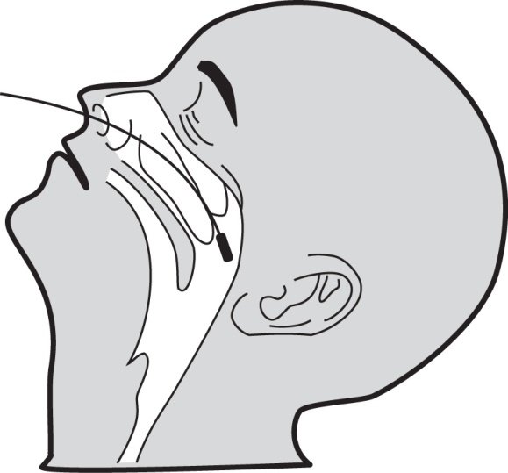
To collect Nasopharyngeal Swab Specimen

Using a flocked swab in the Status™ COVID-19 kit, gently insert the swab approximately ¼” into the anterior nares (just inside the nasal orifice). Rotate the swab a few times, and repeat in the second nostril, using the same swab.

Test Procedure
Procedural Notes
• The test procedure below must be followed to obtain accurate and reproducible results.
• Reagents, specimens, and devices must be at room temperature (18-30°C) for testing.
• Do not open the foil pouch until you are ready to perform the test.
• Several tests may be run at one time.
• Label the device with the patient identification or control to be tested.
• Place test device on a level surface.
Test Procedure
1. Tear the tab off the Extraction Reagent capsule and squeeze it to dispense all of the solution into the Extraction Well of the test device.
2. Insert the specimen swab into the Swab Stand in the Extraction Well and rotate it 3 times to mix the specimen. Incubate for 1 minute with the swab in Extraction Well. Rotate swab 3 times again to mix the specimen. Remove from Swab Stand and discard the swab.
3. Raise the device upright (see diagram). Let it stand for 1-2 seconds. Gently tap the device to ensure that the liquid flows into the hole. Lay the device back down onto the flat surface. Start timing.
4. Read test results at 15 minutes. Do not read test results after 15 minutes.

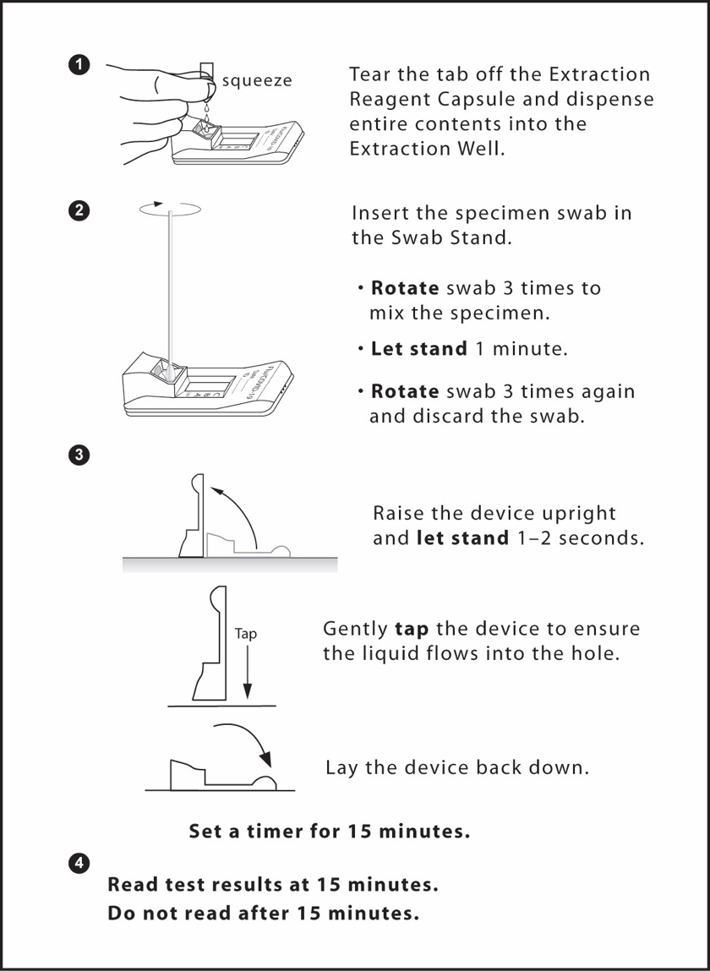

Interpretation of Results
Positive: Determination of a positive result is made at fifteen (15) minutes. A reddish purple Control line (C position) and a reddish purple Test line of CoV19 position indicate that SARS-CoV-2 antigen has been detected.

Note: The Test line (reddish purple line) may vary in shade and intensity (light or dark, weak or strong) depending on the concentration of antigen detected. The intensity of the Control line should not be compared to that of the Test line for the interpretation of the test result. Even a light or faint Test line must be interpreted as a positive result.

Negative: A reddish purple Control line (C position) only, with no CoV19 positions, indicates SARS-CoV-2 antigen has not been detected. Determination of negative results should not be made before 15 minutes.

Invalid: A reddish purple line should always appear at the Control line position (C position). If a line does not form at the Control line position in 15 minutes, the test result is invalid and the test should be repeated with a new Status™ COVID-19 test device.

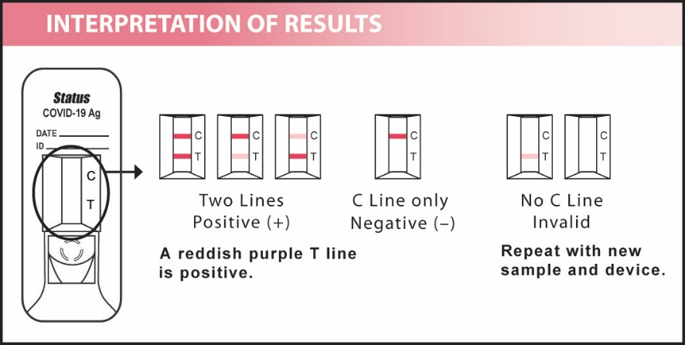

Limitations
• A negative test result does not exclude infection with SARS-CoV-2. Therefore, the results obtained with the Status™ COVID-19 test should be used in conjunction with clinical findings to make an accurate diagnosis. Additional testing is required to confirm, in consultation with state or local public health departments.
• This test detects both viable (live) and non-viable SARS-CoV-2. Test performance depends on the amount of virus (antigen) in the specimen and may or may not correlate with viral culture or molecular assay results performed on the same specimen.
• Status™ COVID-19 uses highly target specific monoclonal antibodies. As in most immunoassays, it may fail to detect, or detect with less sensitivity, inﬂuenza A viruses that have undergone minor amino acid changes in the target epitope region.
• Performance of the Status™ COVID-19 test has not been established for monitoring antiviral treatment of inﬂuenza and SARS-CoV-2.
• The performance of this test has not been evaluated for use in patients without signs and symptoms of respiratory infection.
• This test cannot rule out diseases caused by other bacterial or viral pathogens.
• The performance of this test has not been evaluated for specimen types other than those specified in the Intended Use.
• The performance of this test has not been evaluated for immunocompromised individuals.
• The performance of the Status™ COVID-19 test was not evaluated for SARS-CoV-2 detection with samples collected in viral transport media.
• Positive and negative predictive values are highly dependent on prevalence. False negative test results are more likely during peak activity when prevalence of disease is high. False positive test results are more likely during periods of low activity when prevalence is moderate to low.

User Quality Control
Internal Quality Control:
Each Status™ COVID-19 test device has built-in controls. The Control line at the C position can be considered as an internal positive procedural control; i.e., a proper amount of sample was used, sample was properly added to the Extraction Well, sample migrated properly, and the reagent system worked properly. A distinct reddish-purple Control line should always appear if the test has been performed correctly. If the Control line does not appear, the test result is invalid and a new test should be performed. If the problem persists, contact LifeSign at 800-526-2125 or 732-246-3366 for technical assistance. A clear background in the Test Result Window is considered an internal negative procedural control. If the test is performed correctly and the Status™ COVID-19 test device is working properly, the background in the Test Result Window will be clear, providing a distinct result.

External Quality Control:
Good laboratory practice includes the use of external controls to ensure proper kit performance. It is recommended that external control testing be performed with each new operator and before using a new lot or shipment of Status™ COVID-19 kits to confirm the expected Q.C. results, using the external controls provided in the kit. The frequency of additional Q.C. tests should be determined according to your laboratory's standard Q.C. procedures and local, State and Federal regulations or accreditation requirements. Upon confirmation of the expected results, the kit is ready for use with patient specimens. If external controls do not perform as expected, do not use the test results. Repeat the tests or contact LifeSign Technical Services. The built-in reddish purple Control line indicates only the integrity of the test device and proper fluid flow.
The Status™ COVID-19 kit contains two external control swabs. Test the control swabs in the same manner as patient specimens. When the positive control is tested, reddish purple lines appear at the C as well as CoV19 positions. When the negative control is tested, a reddish purple line appears at the C position only.
If the controls do not perform as expected, do not report patient results.
The use of positive and negative controls from other commercial kits has not been established with Status™ COVID-19 test.

Expected Values
The rate of positives in COVID-19 testing varies depending on many factors, including the specimen collection method, the disease prevalence, and the geographic location.

Performance Characteristics

Clinical Performance

A prospective study was performed with one hundred nine (109) direct nasopharyngeal swabs. The samples were collected from symptomatic patients suspected of infection with COVID-19, at two Point of Care (POC) CLIA waived clinical sites. To be enrolled in the study, patients had to present at the participating study site with signs and symptoms of respiratory infection generally observed from SARS-CoV-2 during the study period. Patients presenting within five (5) days of symptom onset were included in the study. Three nasopharyngeal swabs were collected from each patient; one swab to be tested using a reference for the detection of SARS-CoV-2, an FDA Emergency Use Authorized RT-PCR assay for the detection of SARS-CoV-2 (TaqPath COVID-19 Combo Kit, and BD SARS-CoV-2 Reagents for BD MAX system) and one additional swab to be tested at the study site. One swab was tested with Status™ COVID-19 test.

Patient Demographics

Patient demographics (age, elapsed time from date of symptom onset) are available for the 109 patients participating in this clinical study. COVID-19 Positive results are broken down by age and days post symptom onset in the tables below.

Patient Demographics (COVID-19 positive = 39)
Age | Status™ COVID-19
 | Total # | # COVID-19  Positive | Prevalence
≤ 5 years | 0 | N/A | N/A
6 to 21 years | 16 | 9 | 56.3 %
22 to 59 years | 74 | 23 | 31.1 %
≥60 years | 18 | 7 | 38.9 %
Unknown¹⁾ | 1 | 0 | N/A
1) One patient did not provide age information.

Specimen Positivity Breakdown Based On Days Post Onset (COVID-19 positive = 39)
Days Posts Symptom Onset | Status™ COVID-19
 | Total # Tested | # COVID-19 Positive | % Positive
0¹⁾ | 22 | 15 | 68.2 %
1²⁾ | 41 | 12 | 29.3 %
2 | 20 | 5 | 25.0 %
3 | 11 | 4 | 36.4 %
4 | 5 | 3 | 60.0 %
5 | 3 | 0 | 0 %
6 | 1 | 0 | 0 %
7 | 2 | 0 | 0 %
14 | 1 | 0 | 0 %
Unknown³⁾ | 3 | 0 | 0 %
1) One specimen was COVID-19 negative by Status™ COVID-19 and COVID-19 Positive by reference extracted RT-PCR
2) Two specimens were COVID-19 negative by Status™ COVID-19 and COVID-19 Positive by reference extracted RT-PCR
3) Three specimens did not provide days post symptom onset data.

Status™ COVID-19 performance compared to reference PCR: COVID-19 (SARS-CoV-2)
 |  | Reference Extracted RT-PCR: SARS-CoV-2 |  |  | Performance  (95% CI)
 |  | Positive | Negative | Total
Status ™ COVID-19 | COVID-19  Positive | 39 | 0 | 39 | Sensitivity: 92.9%  95% CI: 81.0% to 97.5%
 | COVID-19  Negative | 3 | 67 | 70 | Specificity: 100%  95% CI: 94.6% to 100.0%
Total |  | 42 | 67 | 109

Sensitivity: 92.9 % (95% CI: 81.0% to 97.5.5 %)
Specificity: 100.0 % (95% CI: 94.6 % to 100.0 %)
Positive Predictive Value: 100.0 % (95% CI: 91.0 to 100 %)
Negative Predictive Value: 95.7 % (95% CI: 88.1 % to 98.5 %)

Analytical Performance

Limit of Detection (LOD)

Limit of detection (LOD) for SARS-CoV-2 in the Status™ COVID-19 was determined by evaluating different concentrations of heat inactivated SARS-CoV-2 virus. Natural nasopharyngeal swab specimens were obtained from healthy donors and confirmed negative for COVID-19 using the Status™ COVID-19 test. Negative natural nasopharyngeal swab specimens were eluted in PBS. Swab elutes were combined and mixed thoroughly to create a negative clinical matrix pool to be used as the diluent. Heat inactivated SARS-CoV-2 virus was diluted in this natural nasopharyngeal swab matrix pool to generate virus dilution for testing.

A series of dilutions (1/5, 1/10 and 1/100) of the heat inactivated virus were prepared into negative clinical matrix and then tested in triplicate.
The lowest concentration (L2, 1.6 x 10⁴ TCID₅₀/mL) was selected for evaluating the LOD range finding.
A series of further 2- to 10-fold dilutions were prepared from the last concentration above (L2, 1.6 x 10⁴) for finding the LOD range. Dilutions of 1/2, 1/4, 1/5, 1/6, 1/7, 1/8 and 1/10 were prepared into the negative clinical matrix. The lowest concentration demonstrating 3 of 3 positives (L7, 2.7 x 10³ TCID₅₀/mL) was chosen as a tentative LOD. The LOD was determined as the lowest virus concentration that was detected ≥ 95% of the time (i.e., concentration at which at least 19 out of 20 replicates tested positive).

LOD for SARS-CoV-2 in natural nasopharyngeal swab matrix was confirmed as 2.7 x 10³ TCID₅₀/mL in the Status™ COVID-19 test.
Concentration | Number of positive/Total tested | % Detected
2.7 x 10³ TCID₅₀/mL | 20/20 | 100 %

Analytical Speciﬁcity (Cross-reactivity)

The analytical Speciﬁcity Cross-reactivity of SARS-CoV-2 was established for a total of 28 normal or pathogenic flora that are reasonably likely to be encountered in clinical specimens. The results are shown in the tables below.

Potential Cross-reactant | Concentration
Human coronavirus 229E | 1.0 x 10⁵ TCID₅₀/mL
Human coronavirus OC43 | 1.0 x 10⁵ TCID₅₀/mL
Human coronavirus NL63 | 1.0 x 10⁵ TCID₅₀/mL
Adenovirus C1 | 1.0 x 10⁵ TCID₅₀/mL
Human Metapneumovirus(hMPV) | 3.89 x 10⁴ TCID₅₀/mL
Parainfluenza virus 1, C35 | 1.0 x 10⁵ TCID₅₀/mL
Parainfluenza virus 2, Greer | 1.0 x 10⁵ TCID₅₀/mL
Parainfluenza virus 3, C243 | 1.0 x 10⁵ TCID₅₀/mL
Parainfluenza virus 4, CH19503 | 1.0 x 10⁵ TCID₅₀/mL
Influenza A A/California/2/2014(H3N2) | 1.0 x 10⁵ TCID₅₀/mL
Influenza A A/Hong Kong/8/68(H3N2) | 1.0 x 10⁵ TCID₅₀/mL
Influenza A A/California/07/2009(H1N1) | 1.0 x 10⁵ CEID₅₀/mL
Influenza B B/Russia/69 | 1.0 x 10⁵ CEID₅₀/mL
Influenza B B/Florida/02/06 | 1.0 x 10⁵ TCID₅₀/mL
Human enterovirus 71Strain: H | 1.0 x 10⁵ TCID₅₀/mL
Human respiratory syncytial virus, A2 | 1.0 x 10⁵ PFU/mL
Rhinovirus 2060 | 1.0 x 10⁵ PFU/mL
Haemophilus influenza | 4 x 10⁴ cfu/mL
Streptococcus pneumoniae | 2.0 x 10⁴ cfu/mL
Streptococcus pyogenes, Bruno | 4.0 x 10⁶ cfu/mL
Candida albicans | 1.0 x 10⁶ cfu/mL
Bordetella pertussis, 18323 | 1.0 x 10⁶ cfu/mL
Mycoplasma pneumoniae | 1.0 x 10⁶ cfu/mL
Chlamydia pneumoniae TW-183 | 1.0 x 10⁶ IFU/mL
Legionella pneumophila | 1.0 x 10⁶ cfu/mL
Pnemocystis jirovecii | 1.0 x 10⁶ cfu/mL

None of the tested substances demonstrated cross-reactivity with the SARS-CoV-2 antibodies. All samples prepared in clinical negative matrix produced the expected negative result, and all samples prepared at 3 x LOD produced the expected positive results.

To estimate the likelihood of cross-reactivity with SARS-CoV-2 virus in the presence of organisms that were not available for wet testing, In silico analysis using the basic Local alignment search tool (BLAST) managed by National Center for Biotechnology Information (NCBI) was used to assess the degree of protein sequence homology.
• No protein sequence homology was found between Mycobacterium tuberculosis, and therefore, homology based cross-reactivity can be ruled out.

• The comparison between SARS-CoV-2 nucleocapsid protein, MERS-CoV and human corona virus HKU1 revealed that cross-reactivity cannot be ruled out. Homology for HKU1 and MERS-CoV is relatively low, at 48.5% across 91% of sequence and 36.7% across 82% of the sequence, respectively.

Endogenous Interfering Substances

SARS-CoV-2

The potential interference of endogenous substances with the antibodies used for the detection of COVID-19 was examined by testing eighteen (18) substances in a negative clinical matrix, at 3 x LOD concentrations, in the absence and presence of SARS-CoV-2 virus. The interference study was conducted using medically relevant concentrations of the potentially interfering substances listed below to assess the potential interference of the substances on the performance of the Status™ COVID-19 test.

Interfering substance | Concentration
Mucin | 5.0 mg/mL
Whole blood (human) | 5%
Halls Cough Suppressant/Oral Anesthetic Drops | 1.5 g/mL
Nasacort Allergy 24H | 5%
Rhinocort Allergy Spray | 5%
ZICAM Cold Remedy + Multi-Symptom Relief | 5%
Afrin Nasal Spray | 15%
Cepacol Extra Strength | 1.5 g/mL
Flonase Allergy Relief | 5%
Oseltamivir | 5 mg/mL
Saline nasal spray | 15%
NasoGEL(NeilMed) | 5%
Tobramycine | 10 µg/mL
Zanamivir | 282.0 ng/mL
CVS Sinus Relief  Nasal spray | 15%
NasalCrom Nasal spray | 15%
Sore throat phenol spray | 15%
Homeopathic (Alkalol) | 1:10 dilution

High-dose Hook Effect

No high-dose hook effect was observed when tested with up to a concentration of 1.15 x 10⁷ TCID₅₀/mL for SARS-CoV-2 virus.

Symbols
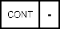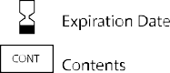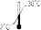
Reagent Capsule
MTD COVID-19
An in vitro immunocromatographic assay for the qualitative detection of SARS-CoV-2 antigen directly from nasal specimens
CAP

Manufactured by
Princeton BioMeditech Corporation
4242 US Hwy1
Monmouth Junction, NJ 08852
+1-732-274-1000
www.pbmc.com

Manufactured for:
A PBM Group Company
LifeSign LLC
85 Orchard Road
Skillman, NJ 08558
+1-732-246-3366
www.lifesignmed.com

Authorized Representative:
MT Promedt Consulting GmbH
Altenhofstrasse 80
66386 St. Ingbert, Germany
+49-68 94-58 10 20

